**Abstract**

Fingerprint identification is an important step in criminal investigation (Figure 1). In this project we will be considering some training fingerprint images using which you are going to build a fingerprint identification system using RBF kernel based Support Vector Machines. We will be considering a test set A, of some fingerprint images that you will use to evaluate the performance of the classifier.

Figure 1: Photo license: Creative Commons (Attribution 3.0)

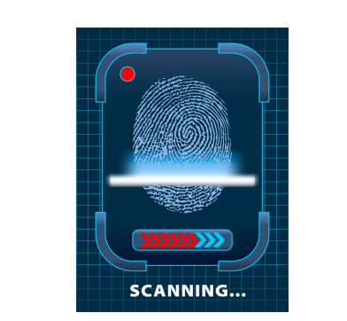

**1 Program statement**

* Download the training dataset of 126 fingerprints of 21 persons (6 thumb fingerprints per person) from this link <http://bit.ly/2phOMcN> . The file names follow x y.bmp convention, where x is the identification number of a person, while y is a serial number of fingerprint snap for that person. All images are in BMP format, and resolution is 256 × 256.
* You need to do some preprocessing to prepare the feature vector for each fingerprint image of a person. For a thorough outline of the preprocessing, please read a project report by Xuan Xu [Poster link: <https://goo.gl/cfuZKD>] [Report link: <https://goo.gl/GvHBWc>]
* Build a multi-class classifier from the non-linear support vector machines (RBF kernel) using the training set features you extracted in the previous step. Since SVM is a binary classifier, in order to make it do multi-class (i.e., 21 classes in this assignment) prediction, you need to use the one-vs-all strategy.
* Write a checker program that takes a fingerprint image as input, and based on the model you trained in the previous step prints the identification number of the person that you will get by prediction.
* Use the checker program to see the test A performance. You can tune various parameters of RBF kernel based SVM to get a better decision boundary. I recommend you do the parameter tuning. The test A dataset contains 21 fingerprint images. Download link for this test A dataset is <http://bit.ly/2IrM1yw> .